

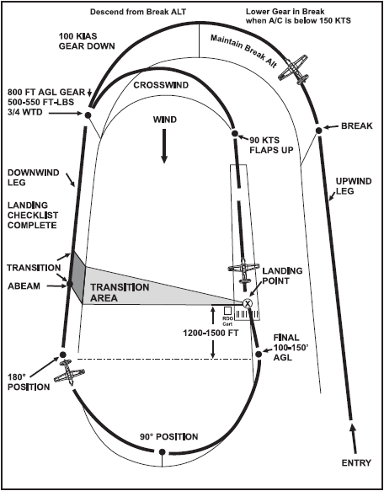

PATTERN SIDE ENTRY

45º AOB

300 FT-LBS
PATTERN SIDE ENTRY
90 KIAS FF

95 KIAS NF

100 KIAS
300 FT# FF

275 FT# NF
85 KIAS FF

95 KIAS NF

